Analog temperature sensor

#### Overview：

This class will use thermistors to print out the temperature values on the serial port.

#### **Materials：**

Arduino Uno x 1

analogTempSensor *1

DuPont wires x 3

#### **Product description :**

A thermistor is a non-linear resistor which is sensitive to temperature and whose resistance changes with temperature. It is usually made of a polycrystalline semiconductor. It has a series of special electrical properties. The most important of these is that its resistance changes significantly with temperature.

Thermistors have a high temperature sensitivity, small thermal inertia, long life, small size, simple structure, and come in various shapes and structures. They are widely used in industrial and agricultural production, science and technology.

They are widely used for temperature measurement, temperature control, temperature compensation, measuring liquid levels, pressure measurement, in fire alarms, for meteorological observations, switch circuit protection, overload protection, voltage spike suppressors, automatic gain adjustment, laser and microwave power measurement and more.

#### **Technical Parameters ：**

Analog signal output  
Temperature Range: -55~+125°C  
Temperature measurement precision: 0.5°C  
Working voltage :DC 5V

#### **Wiring diagram:**

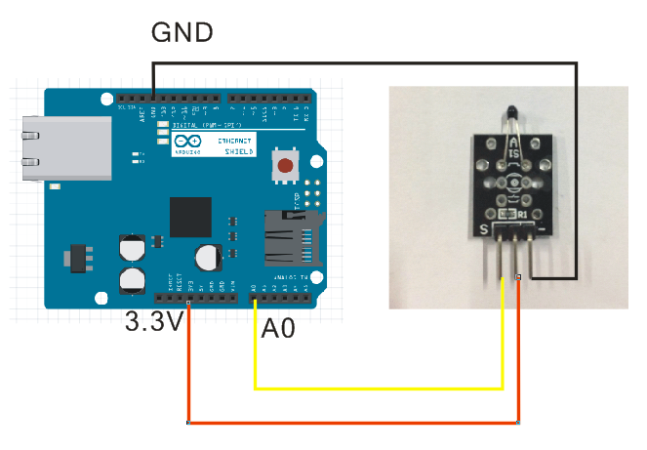

**Example code:**

|  |
| --- |
| **void setup()**  **{**  **// initialize serial communication at 9600 bits per second:**  **Serial.begin(9600);**  **}**  **// the loop routine runs over and over again forever:**  **void loop()**  **{**  **// read the input on analog pin 0:**  **int sensorValue = analogRead(A0);**  **// print out the value you read:**  **Serial.println(sensorValue);**  **delay(1000); // delay in between reads for stability**  **}** |

**Experimental phenomena：**

The temperature should be printed out on the Arduino’s serial port.

